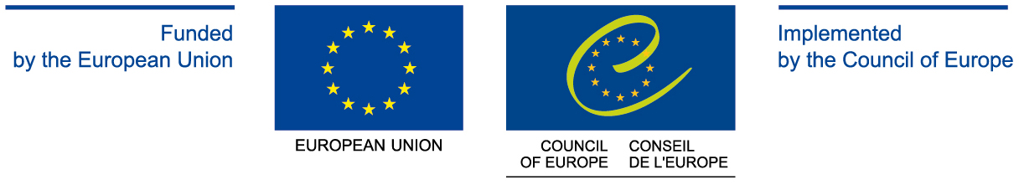

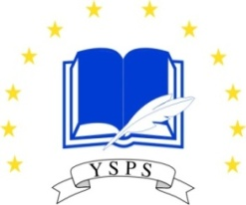

MINUTES OF THE MEETING

WOMEN IN PUBLIC AND POLITICAL LIFE

SEMINAR ON “WOMEN’S PARTICIPATION IN PUBLIC LIFE AND POLITICS AS A PREREQUISITE OF EQUILIBRATED DEMOCRACY”

14-17 March 2013
Tsakhkadzor, Armenia

Introduction

The seminar of the Yerevan School of Political Studies on “Women in Public and Political Life” was organized on 14-17 March 2013 in Tsakhkadzor, Armenia.
The main topic of the seminar was “Women’s Participation in Public Life and Politics as a Prerequisite of Equilibrated Democracy”.

In general the seminar distinguished with its high representation of local experts of the field.
Particularly:
- Ms. Jemma HASRATYAN, President of Armenian Association of Women with University Education, Director of the Center of Gender Studies
- Ms. Margarita SARGSYAN, Ministry of Labour and Social Affairs of the Republic of Armenia
- Ms. Lilit ZAKARYAN, Vice-President of Armenian Association of Women with University Education, Senior Research Fellow of the Institute of History of the Armenian National Academy of Sciences
- Ms. Irina SHAHINYAN, Armenian Association of Women with University Education
- Ms. Anahit AGHOYAN, Coordinator of the Kotayk center for Civic Initiatives of Armenian Association of Women with University Education
- Mr. Harutyun MARZPANYAN, Lecturer at University of Economy and Law after Avetik Mkrtchyan
- Mr. Vladimir OSIPOV, Senior Researcher Fellow at the Institute of Philosophy, Sociology and Law of the Armenian National Academy of Sciences
- Ms. Anahit HARUTYUNYAN, President of “Spiritual Armenia” NGO; Center of Gender Studies
- Ms. Gayane MEROYAN, Program coordinator of Armenian Association of Women with University Education
- Mr. Hovhannes HOVHANNISYAN, Faculty of Philosophy and Logics, Yerevan State University
Special session was devoted to the meeting of participants with Ms. Hermine NAGHDALYAN, Vice-President of the National Assembly of the Republic of Armenia; Chairperson Women’s Council of Republican Party of Armenia; PACE Member (1999-2012).

This was an exceptional opportunity for participants to interact and establish contacts with others coming from different social and professional background contributing thus to the processes of socialization.
The seminar was conducted according to the planned agenda with no deviations and served its initial purpose.
The event was attended by Armenian women leaders. The 40% were invited from different regions of Armenia. The participants represented:
- National Assembly of the Republic of Armenia
- Government of the Republic of Armenia
- Ministries of the Republic of Armenia
- Political Parties of Armenia (“Republican Party of Armenia”, “Prosperous Armenia Party”, “Armenian Revolutionary Federation”, “Heritage Party”, “Rule of Law Party”)
- City Municipalities
- Journalists
- NGO sector
- Etc.

Detailed description of the Activity
Concepts of gender are dynamic and may change over time. When drafting the current seminar programme, it was important to approach gender issues broadly, to analyze the current roles and relationships of men and women in Armenia as well as their inclusion and participation in the political and public life of the country and to determine how any differences could have either a positive or negative impact on the strategy going forward. The seminar addressed the achievements of Armenian women and the challenges they face in realizing their rights and achieving gender equality.

The discussion highlighted both the capacity and resources that Armenian women can lend to the development of their country but also some of the serious institutional barriers that are preventing them from doing so.
The seminar was composed of 5 sessions with their separate subtopics. They were the following:

- Culture of Gender and Political Participation
1.1. Gender as Socio-Cultural Paradigm
1.2.Women’s Political Participation as a Prerequisite of Society’s Democratization. The Role of Political Parties in the Stimulation of Women Activeness
1.3. Women’s Political Participation Incentives and Obstacles. Traditional Views and Stereotypes on Women’s Political Participation in Public Perception. Women’s Self-discrimination
1.4. Women’s Participation in Parliamentary Elections of 2012

- Political Leadership: Types, Peculiarities and Practices
  - Leadership: Types, Peculiarities and Practices
  - Leadership Promotion as Women’s Political Participation Prerequisite and a Factor of Political Initiatives Development

Women’s Accomplishments and Awareness as a Prerequisite of Professional and Political Career

- Gender Policy: the Perspectives of Men’s and Women’s Equal Rights and Equal Opportunities Advancement in Armenia
3.1. Armenia’s Government Gender Policy Concept and NGO’s Role in its Implementation

3.2. UN Convention on the Elimination of All Forms of Discrimination against Women and Republic of Armenia’s Periodic Reports on the Implementation of the Convention

3.3. Women’s Participation in Elections of Local Self-Government Bodies of 2012: Results Evaluation
3.4. The Nature of the Gender Violence. Causes and Practices. Types of the Gender Violence
3.5. Women Movement in Armenia: Problems and Prospective

- Gender Issues of Labor Market and Employment. Gender Analysis
4.1. Gender Issues of Labor Market and Employment: Sex-based Discrimination
4.2. Gender Factor of Human Development
4.3. Gender Analyze: Goal, Principles, Steps

- The Perspectives Civil Society Development in Armenia. Social Dialogue
  - Civil Society Development Problems in Armenia
  - Culture of Societal-Political Dialogue

Round Table was devoted to the “Problems of Women and Women Movement in Armenia: Traditions and Current Reality”. Particularly the following topics were discussed:
- Women Movement in Armenia in the End of the 19th Century and Beginning of the 20th Century: International Experience and Armenian Reality
- Women Movement in Armenia: Historical Past and Present Period

During the seminar Working Groups practice was used, which is targeted at detecting and highlighting, as well as analyzing the most topical and actual issues of the topic. The workshops are a good research tool to be thoroughly involved in the problem, be better prepared, carry a thorough study and become more specialized and aware at a higher level at the topic, express views before a multi-layered auditorium.
The working group reports and presentations were well prepared and presented in PPT format.
Based on the lectures and presentations of the experts as well as small group discussions of the seminar participants Country Report on “Participation of Women in Public and Political Life” was written which highlighted the problems raised and questions discussed.

SUMMARY

The seminar was a very effective platform for practical transformation, understanding and reflection as well as for meeting the specific goals of providing young mid-career individuals with awareness, knowledge, capacity and skills.
In addition to the in-depth information, content material and practical skills conveyed to participants, the seminar’s importance consisted also in bringing together active members of different regions of Armenia. They were glad to have chance to get thoroughly acquainted with one another.
Electronic support materials, presentations have been sent to participants before and after the event.
YSPS Administration received “thank you” letters by participants as well as comments and suggestions regarding the possible organization of similar seminars.

