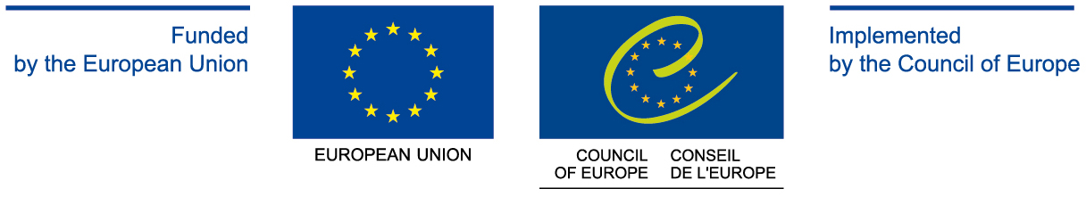

PARTNER IN ARMENIA



SEMINAR ON
WOMEN IN PUBLIC AND POLITICAL LIFE

LIST OF PARTICIPANTS

15-17 March 2013
Tsaghkadzor/ Armenia
SEMINAR PARTICIPANTS

№ | FULL NAME | FUNCTION
 | ABRAHAMYAN Ida | Ministry of Territorial Administration of the Republic of Armenia
 | ARMAGANOVA Gayane | Armenian Association of Women with University Education
 | BAGHDASARYAN Ruzan | Government of the Republic of Armenia
 | BARSEGHYAN Armine | Republican Party of Armenia
 | CHAKHMAKHCHYAN Medora | Rule of Law Party
 | GABRIELYAN Anahit | Municipality of Hrazdan City, Kotayk Region/ Armenia
 | GHAZARYAN Armine | Heritage Party
 | GRIGORYAN Srbuhi | Agrarian University of the Sisian Branch; "Voice of Sisian" Newspaper, Syunik Region/ Armenia
 | GYULAZYAN Anahit | Municipality of Spitak City, Lori Region/ Armenia
 | HAKOBYAN Aghavni | Armenian State University of Economics
 | HARUTYUNYAN Ani | Armenian Revolutionary Federation
 | HARUTYUNYAN Hasmik | "Azg" Newspaper; “ProMED - Gender” NGO
 | HOVHANNISYAN Violetta | Standing Committee on European Integration of the National Assembly of the Republic of Armenia
 | KHACHATRYAN Anahit | Municipality of Artashat City, Ararat Region/ Armenia
 | KHACHATRYAN Narine | “Golden Middle” NGO, Lori Region/ Armenia
 | KOCHARYAN Irina | Prosperous Armenia Party
 | KYUREGYAN Armenuhi | Vanadzor State Pedagogical Institute; Association of Civic Initiatives of Lori Center, Lori Region/ Armenia
 | MANUKYAN Eva | Yerevan School of Political Studies
 | MANTASHYAN Astghik | National Assembly of the Republic of Armenia
 | MELIK-MARTIROSYAN Tatevik | Government of the Republic of Armenia
 | MARGARYAN Anush | "Ararat" TV Studio, Ararat Region/ Armenia
 | MELIKYAN Narine | Capital Asset Management
 | MKRTUMYAN Elina | Konrad Adenauer Foundation
 | TOROZYAN Ruzanna | “Goris Resource Center - Women's Development Fund” NGO, Syunik Region/ Armenia
 | TSAKANYAN Knarik | Standing Committee on Economic Affairs of the National Assembly of the Republic of Armenia
 | VANETSYAN Nonna | Ministry of Economy of the Republic of Armenia

SEMINAR EXPERTS

 | AGHOYAN Anahit | Kotayk center for Civic Initiatives of Armenian Association of Women with University Education
 | HASRATYAN Jemma | Armenian Association of Women with University Education;  Center of Gender Studies
 | HARUTYUNYAN Anahit | “Spiritual Armenia” NGO; Center of Gender Studies
 | HOVHANNISYAN Hovhannes | Faculty of Philosophy and Logics, Yerevan State University
 | MARZPANYAN Harutyun | University of Economy and Law after Avetik Mkrtchyan
 | MEROYAN Gayane | Armenian Association of Women with University Education
 | OSIPOV Vladimir | Institute of Philosophy, Sociology & Law of the Armenian National Academy of Sciences
 | SARGSYAN Margarita | Ministry of Labour and Social Affairs of the Republic of Armenia
 | SHAHINYAN Irina | Armenian Association of Women with University Education
 | ZAKARYAN Lilit | Armenian Association of Women with University Education

