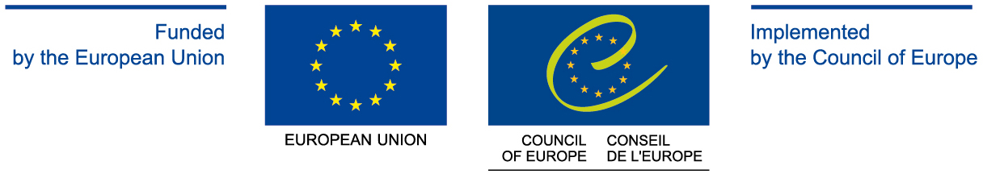

National co-ordinators for Eastern Partnership Facility

Armenia Mr Ara Margaryan, Counsellor, Council of Europe Desk, Ministry of Foreign Affairs (e-mail: ara.margarian@mfa.am )

Mr Mher Margaryan, Counsellor, Head of the EU Division, Ministry of Foreign Affairs (as replacement to Mr Ara Margarian) (e-mail: M.Margaryan@mfa.am )

Azerbaijan Ms Farah Ajalova, First Secretary of the Department of Human Rights, Democratisation & Humanitarian Affairs, Ministry of Foreign Affairs (e-mail : f_ajalova@mfa.gov.az )

Georgia Ms Ekaterina Kokaia, Senior Specialist, Georgia State Minister’s Office on European and Euro-Atlantic Integration (e-mail: ekaterine.kokaia@eu-nato.gov.ge )

Ms Rusudan Mikhelidze, Deputy Head of Analytical Department, Head of Strategic Policy Development Unit, Ministry of Justice of Georgia (e-mail: rmikhelidze@justice.gov.ge )

Mr Giorgi JOKHADZE
The new project coordinator for cybercrime as from August
Lawyer, Data Exchange Agency
e-mail: gjokhadze@yahoo.com, gjokhadze@dea.gov.ge

Ms Tamar Tomashvili, Head of Public International Law Department, Ministry of Justice of Georgia (e-mail: ttomashvili@justice.gov.ge )

Moldova Ms Augustina Bolocan-Holban, Head of the Treaties & European Integration Division, Ministry of Justice (e.mail: bolocan-holban@justice.gov.md )

Ukraine Ms Valeria Lutkovska, Government Agent to the European Court of Human Rights, Ministry of Justice (e-mail: lutkovska@minjust.gov.ua )
Contact persons on the joint initiatives of the Council of Europe and the EU within the Eastern partnership:
Ms Olga Stefanishyna, Head of Division of the cooperation with the European Union, Ministry of Justice of Ukraine (e-mail: o.kravets@sdla.gov.ua )

Mr Yegor Bozhok, Head of division of justice, freedom and security, humanitarian and transboarder co-operation, Ministry of Foreign Affairs of Ukraine (e-mail: o.bozhok@mfa.gov.ua )

Belarus Mr Roman Romanovsky, Head of Department on European Co-operation, Deputy Director General on Europe (e-mail: belmission_coe@mail.by )

