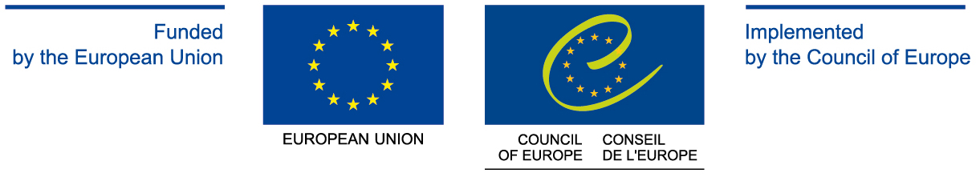

European Union Delegations in Partnership Countries

Delegation of the European Union to the Republic of Armenia
21 Frik Street, Yerevan 0002
Armenia
Telephone: + 374 (10) 54 64 94
Fax: + 374 (10) 54 64 95
E-mail: Delegation-Armenia@eeas.europa.eu

Delegation of the European Union to Azerbaijan
11th floor, 90A Nizami St.
Landmark III, Baku
Telephone: (+994-12) 497 20 63
Fax: (+994-12) 497 20 69
E-mail: Delegation-Azerbaijan@eeas.europa.eu

Delegation of the European Union to the Republic of Belarus
34A/2 Engels Street
Minsk 220030, Belarus
Telephone: + 375 17 328 66 13
Fax: + 375 17 289 12 81
E-mail: delegation-belarus@eeas.europa.eu

Delegation of the European Union to Georgia
38, Nino Chkheidze St.
Tbilisi 0102, Georgia
Telephone: (+995 32) 294 37 63
Fax: (+995 32) 294 37 68
E-mail: delegation-georgia@eeas.europa.eu

Delegation of the European Union to Moldova
Kogalniceanu Street nr 12
MD 2001 Chisinau,
Republic of Moldova
Telephone: (+373 22) 50 52 10
Fax: (+373 22) 27 26 22
E-mail: Delegation-Moldova@eeas.europa.eu

Delegation of the European Union to Ukraine
10 Kruhlo-Universytetska St.
Kyiv, 01024 Ukraine
Telephone: +380 (44) 390 8010
Fax: +380 (44) 253 4547
E-mail: delegation-ukraine@eeas.europa.eu
delegation-ukraine-press@eeas.europa.eu (Press Information Section)

