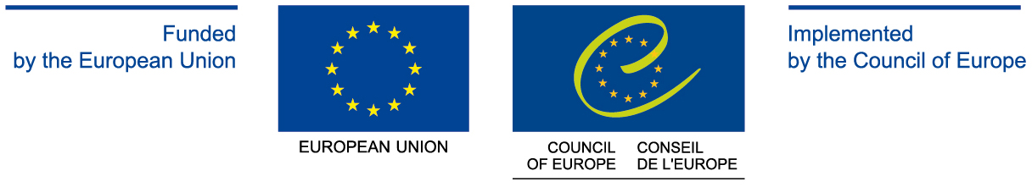

Delegation of the European Union to the Council of Europe

Ms Luisella PAVAN-WOOLFE
Ambassador
Head of the Delegation of the
European Union
to the Council of Europe
E-mail : Luisella.Pavan-Woolfe@eeas.europa.eu

Ms Katerina MARKOVOVA
Deputy to the
Head of the Delegation of the
European Union
to the Council of Europe
E-mail: Katerina.MARKOVOVA@eeas.europa.eu

General e-mail: delegation-strasbourg-1@eeas.europa.eu

