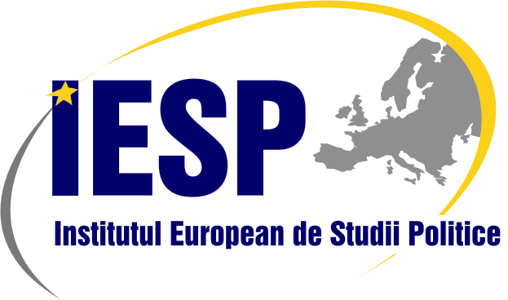  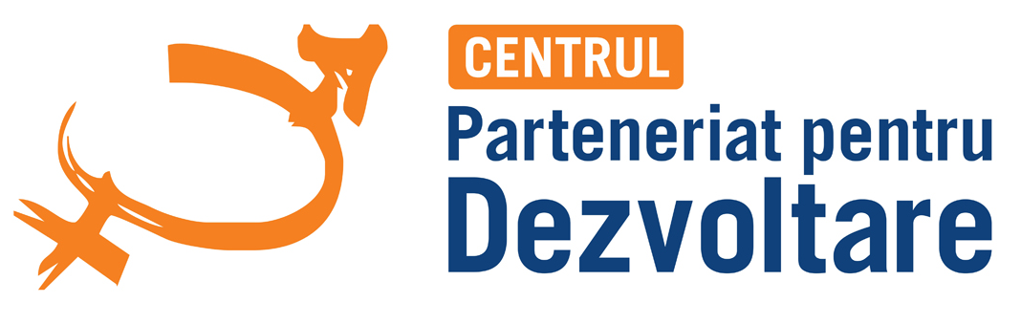 |  |  |  | 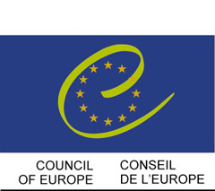
Participation of women
in public and political life in Moldova
– Current Situation and Main Trends
NATIONAL WORKSHOP ON GENDER ISSUES
chisinau, APRIL 26-28 2013

PROGRAM
FRIDAY APRIL 26th - day one
09.30hrs | Venue of the Conference: Conference Hall Regency Hotel, (Str. Sfatul Tarii 17)  Registration of the participants to the Conference
10.00hrs | Welcoming address  Dirk Schuebel, Head of the Delegation of the European Union to Moldova  Ingrid Tersman, Ambassador of Sweden in Moldova  Viorel Cibotaru, Director of the European Institute for Political Studies of Moldova  Alexei Buzu, Director of the Center “Partnership for Development”
10.30hrs | SESSION 1
 | ASSESSING WOMEN’S POLITICAL ENGAGEMENT IN MOLDOVA – TRENDS, and APPROACHES
 | Moderator: | Alexei Buzu, Director, Center “Partnership for Development”
 | Speakers: | Iurie Ciocan, Head, Central Electoral Committee  Catinca Mardarovici, Executive Director, NGO “Women’s Political Club 50/50”  Andrei Brighidin, Gender Expert, Program Coordinator, East European Foundation
11.30hrs | Questions, answers, discussion - 30 minutes  Coffee break
12.00hrs | Small Groups Work  Questions for discussions: Quota provision: the best solution for Republic of Moldova?, MDG 3: where we are and what should we achieve in 2015?, Women organizations within political parties: launch ramp or obstacle for advancement of women in politics?  Facilitators: Catinca Mardarovici, Alexei Buzu
13.00hrs  13.30hrs | Presentation of the results of the Small Groups Debates, Case Study and final conclusions of the key speakers  Lunch
14.30hrs | SESSION 2
 | IMPLEMENTATION OF THE NATIONAL ACTION PLAN AND LAW ON EQUALITY BETWEEN WOMEN AND MEN
 | Moderator: | Valentina Bodrug-Lungu, President, NGO “Gender-Center”
 | Speakers: | Lilia Pascal, Head of the Department on gender policies and domestic violence prevention, Ministry of Labor, Social protection and Family  Valentina Bodrug-Lungu, gender expert, Gender-Center NGO
 | Questions, answers, discussion - 30 minutes
16.00hrs | Coffee break
16.30hrs  17.30hrs | Small Groups Work  Questions for discussion: Implementation of the legal framework on gender equality, Barriers and Perspectives for improvement, Legal culture of the population: how to increase it?  Facilitators: Valentina Bodrug-Lungu, Daniela Terzi-Barbarosie  Presentation of the results of the Small Groups Conclusions, Case Studies and final conclusions of the key speakers
Saturday APRIL 27th – day two
10.00hrs | SESSION 3
 | DOMESTIC VIOLENCE AND MATERNITY PROTECTION
 | Moderator: | Elena Burca, President, Women’s organizations Forum in Moldova
 | Speakers: | Angelina Zaporojan-Pargari, Executive Director, Law Center for Women  Marin Maxian, Head of the Department on Public Order, Ministry of Internal Affairs  Olga Manole, Project Coordinator, Promo-LEX, NGO
 | Questions, answers, discussion - 30 minutes
11.30hrs | Coffee break
12.00hrs  13.00hrs | Small Group Work:  Questions for discussion: New provisions on Domestic Violence, Barriers to the implementation of the Law, Legal framework on maternity protection: to what extend and what expenses?  Facilitators: Olga Manole, Liubovi Cibotaru  Presentation of the results of the Small Groups Conclusions, Case Studies and final conclusions of the key speakers
13.30hrs | Lunch
14.30hrs | SESSION 4
 | Women in the labor market
 | Moderator: | Sofia Suleaschi, Director, Winrock Moldova
 | Speakers: | Angela Palii, business woman  Sofia Suleaschi, Director, Winrock Moldova  Raisa Dogaru, Head, The National Agency for Employment, Ministry of Labor, Social Protection and Family
 | Questions, answers, discussion - 30 minutes
16.00hrs | Coffee break
16.30hrs  17.30hrs | Small Groups Work:  Questions for discussion: Gender disparities in employment: what are the main obstacles and possible solutions? How friendly is business environment to women and youth? Gender Pay Gap: causes and interventions.  Facilitators: Sofia Suleanschi, Liubovi Cibotaru  Presentation of the results of the Small Groups Conclusions, Case Studies and final conclusions of the key speakers
Sunday APRIL 28th – day three
10.00hrs | SESSION 5
 | THE ROLE OF EDUCATION AND MASS-MEDIA IN THE GENDER EQUALITY ADVANCEMENT IN MOLDOVA
 | Moderator: | Liliana Vitu-Esanu, Director “Center for Independent Journalism”
 | Speakers: | Petru Macovei, Director, Assocciation for Independent Press, Press Council Represenative  Alina Radu, journalist, „Ziarul de Garda”  Pavel Cerbusca, Deputy Director, Lyceum of the Academy for Science
 | Questions, answers, discussion - 30 minutes
11.30hrs | Coffee break
12.00hrs  13.00hrs | Small Group Work:  Questions for discussion: How to ensure a gender-responsive education in Moldova? Gender sensitiveness of media representatives and productions. Legal provisions and regulations. Recommendations to educational system in Moldova  Facilitators: Liliana Vitu-Esanu, Petru Macovei  Presentation of the results of the Small Groups Case Study and final conclusions of the key speakers
13.30hrs | Lunch
14.30hrs | SESSION 6
 | TRADITONAL CONCEPT OF WOMEN’S ROLE IN MOLDOVAN SOCIETY
 | Speakers: | Olga Nicolenco, Gender expert  Daniela Terzi-Barabrosie, Gender expert – Presentation of the draft for the Country report  Feedbacks, questions, answers, discussion - 30 minutes
16.00hrs Coffee break
16.30hrs CONCLUDING SESSION

Moderator: Viorel Cibotaru, Director of the European Institute for Political Studies in Moldova

