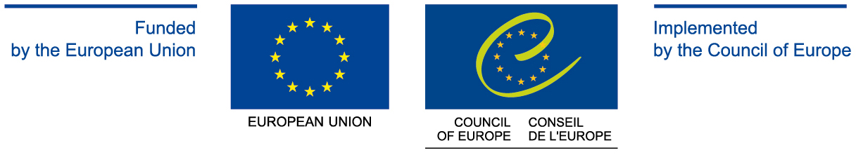

PARTNER IN ARMENIA



SEMINAR ON WOMEN IN PUBLIC AND POLITICAL LIFE

WOMEN’S PARTICIPATION IN PUBLIC LIFE AND POLITICS
AS A PREREQUISITE OF EQUILIBRATED DEMOCRACY

14-17 March 2013
Tsaghkadzor, Armenia

PROGRAMME

Thursday, 14 March 2013

18.45 | Participants arrival to Yerevan
19.00 | Departure for Tsaghkadzor
20.00 | Arrival/Accommodation in “Russia” hotel  8 Magistros str., Tsaghkadzor, Armenia  www.hotelrussia.am
20.30 | Dinner

Friday, 15 March 2013

09.00 | Breakfast
10.00 | Registration of participants
10.15 | OPENING CEREMONY  Mr. Armen ZAKARYAN, Director of the Yerevan School of Political Studies of the Council of Europe  - Presentation of the seminar program  - Presentation of the aim of the seminar
FIRST SESSION
CULTURE OF GENDER AND POLITICAL PARTICIPATION

10.45 | Gender as Socio-Cultural Paradigm  - Questions  - Exchange of ideas and viewpoints
11.30 | Coffee/ tea break
12.00 | Women’s Political Participation as a Prerequisite of Society’s Democratization. The Role of Political Parties in the Stimulation of Women Activeness  - Questions  - Exchange of ideas and viewpoints
13.30 | Lunch
14.30 | Women’s Political Participation Incentives and Obstacles. Traditional Views and Stereotypes on Women’s Political Participation in Public Perception. Women’s Self-discrimination  - Questions  - Exchange of ideas and viewpoints
16.00 | Coffee/ tea break
16.30 | Women’s Participation in Parliamentary Elections of 2012  - Questions  - Exchange of ideas and viewpoints
17.30 | Meeting with Ms. Hermineh NAGHDALYAN, Vice-President of the National Assembly of the Republic of Armenia; Chairperson Women’s Council of Republican Party of Armenia; PACE Member (1999-2012)
19.00 | End of the day
19.00 | Dinner

Saturday, 16 March 2013

08.30 | Breakfast
SECOND SESSION
POLITICAL LEADERSHIP: TYPES, PECULIARITIES AND PRACTICES

09.30 | Leadership: Types, Peculiarities and Practices
10.20 | Break
10.25 | Leadership Promotion as Women’s Political Participation Prerequisite and a Factor of Political Initiatives Development
11.15 | Women’s Accomplishments and Awareness as a Prerequisite of Professional and Political Career
11.45 | Coffee/ tea break
12.15 | - Questions  - Exchange of ideas and viewpoints  - Discussion
THIRD SESSION
GENDER POLICY: THE PERSPECTIVES OF MEN’S AND WOMEN’S EQUAL RIGHTS AND EQUAL OPPORTUNITIES ADVANCEMENT IN ARMENIA

12.30 | Armenia’s Government Gender Policy Concept and NGO’s Role in its Implementation  - Questions  - Exchange of ideas and viewpoint
13.00 | Lunch
14.00 | UN Convention on the Elimination of All Forms of Discrimination against Women and Republic of Armenia’s Periodic Reports on the Implementation of the Convention  - Questions  - Exchange of ideas and viewpoint  - Discussion
14.50 | Break
15.00 | Women’s Participation in Elections of Local Self-Government Bodies of 2012: Results Evaluation  - Questions  - Exchange of ideas and viewpoint
15.30 | The Nature of the Gender Violence. Causes and Practices. Types of the Gender Violence
16.10 | Coffee/ tea break
16.40 | Women Movement in Armenia: Problems and Prospective  - Questions  - Exchange of ideas and viewpoint  - Discussion
17.50 | Break
18.00 | ROUND TABLE  Problems of Women and Women Movement in Armenia: Traditions and Current Reality  - Women Movement in Armenia in the End of the 19th Century and Beginning of the 20th Century: International Experience and Armenian Reality  - Women Movement in Armenia: Historical Past and Present Period  - Questions  - Exchange of ideas and viewpoint  - Discussion
19.15 | End of the day
19.30 | Dinner

Sunday, 17 March 2013

08.00 | Breakfast
FOURTH SESSION
GENDER ISSUES OF LABOR MARKET AND EMPLOYMENT. GENDER ANALYSIS

09.00 | Gender Issues of Labor Market and Employment: Sex-based Discrimination  - Questions  - Exchange of ideas and viewpoint
09.50 | Gender Factor of Human Development  - Questions  - Exchange of ideas and viewpoint
10.30 | Break
10.40 | Gender Analyze: Goal, Principles, Steps  - Questions  - Exchange of ideas and viewpoint  - Discussion
11.30 | Coffee/ tea break
FIFTH SESSION
THE PERSPECTIVES CIVIL SOCIETY DEVELOPMENT IN ARMENIA. SOCIAL DIALOGUE

12.00 | Civil Society Development Problems in Armenia
12.30 | Break
12.40 | Culture of Societal-Political Dialogue
14.00 | - Exchange of ideas and viewpoint  - Discussion  - Evaluation of seminar  - Future Perspectives
14.20 | Lunch
15.30 | Departure

